Task 3 Cybersecurity Bootcamp X OWASP
By Sunny Abraham Mathew
1.Does the target ip respond to ICMP echo (ping) requests (Y/N)?
No ,it was saying host was down.
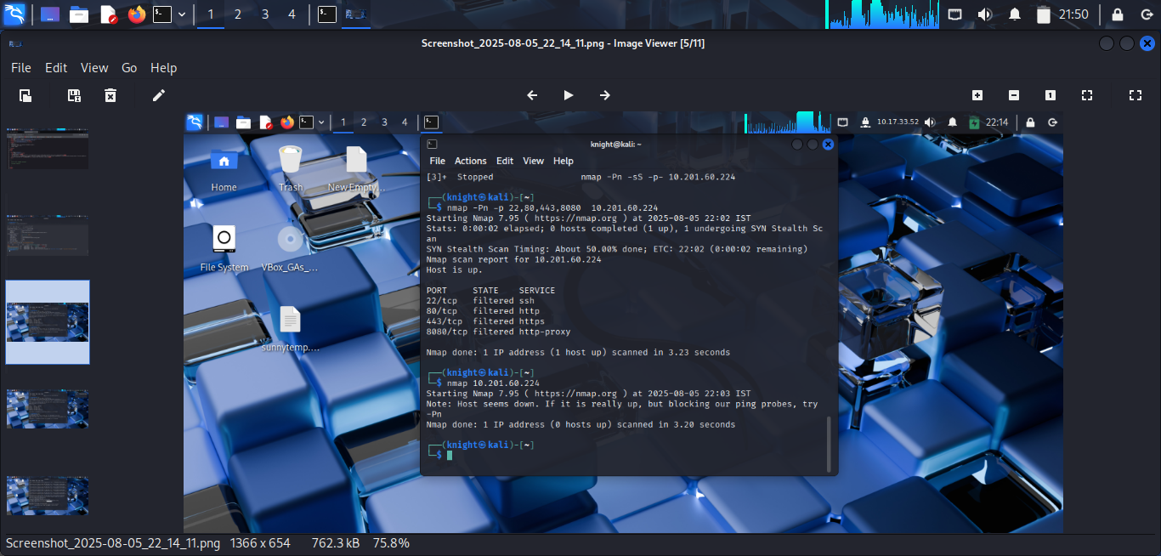
2. Perform an Xmas scan on the first 999 ports of the target -- how many ports are shown to be open or filtered?
999 ports were filtered and it showed no response

3. Perform a TCP SYN scan on the first 5000 ports of the target -- how many ports are shown to be open?
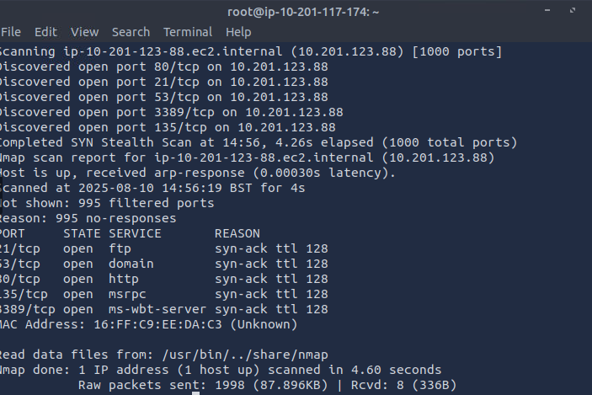
4. Open Wireshark (see Cryillic's Wireshark Room for instructions) and perform a TCP Connect scan against port 80 on the target, monitoring the results. Make sure you understand what's going on. Deploy the ftp-anon script against the box. Can Nmap login successfully to the FTP server on port 21? (Y/N)
Y
